IAR TABLE OF CONTENT

# Introduction

# The CS Market

## Current situation of the CS market (Research on topics)

## Global context (External factors)

## Case studies (Companies & Countries)

Conclusion of part I:

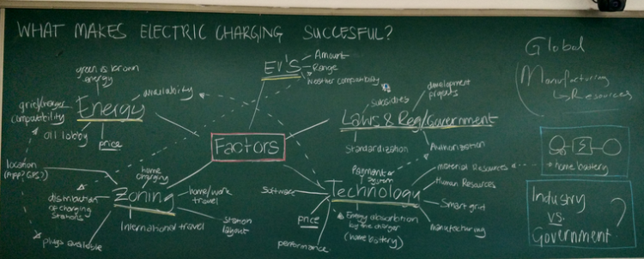

# Analysis

## Relevant Factors

## 5 Forces Analysis

Conclusion of Part II:

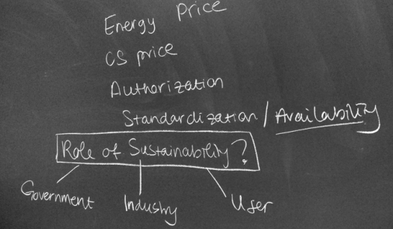

# Outcome

## Conclusion

## Strategy